Answer any four questions
1 | (a) | Sea squirts (Ascidia) have an extensive biochemistry based on vanadium, and some of them have blood containing vanadium compounds. The vanadium present exists in three oxidation states.  Explain, by reference to the Data Booklet, why vanadium can form multiple oxidation states in its compounds whereas calcium does not form oxidation states greater than +2 in its compounds.
 |  |  |  | [3]
 | (b) | Electrode potential values are given below for the reduction of oxygen to water and for the half-reactions which involve V³⁺, VO²⁺ and VO₂⁺. These three ions are commonly found in aqueous solutions of vanadium compounds.  These electrode potential values are obtained under standard conditions, except that pH = 7.
  Electrode potentials | E / V
  VO²⁺(aq) + 2H⁺(aq) + e 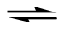 V³⁺(aq) + H₂O(I) | −0.50
  VO₂⁺(aq) + 2H⁺(aq) + e VO²⁺(aq) +H₂O(I) | +0.16
  O₂(g) + 4H⁺(aq) + 4e 2H₂O | +0.98
 |  | (i) | Draw a fully labelled diagram of the apparatus which could be used to measure the standard electrode potential of the VO²⁺/ V³⁺ electrode system.
 |  | (ii) | Predict, using the electrode potentials given above, the oxidation state of vanadium that would be stable in aqueous solution of pH = 7 in the presence of air. Explain how the data allow this prediction to be made.
 |  | (iii) | In reactions that occur in living cells, transition metal ions are often present in the form of biochemical complexes. Suggest why the electrode potential data given above do not allow reliable prediction to be made of the oxidation state of vanadium that would be stable in the presence of oxygen in such reactions.
 |  |  |  | [7]
 | (c) | Explain why aqueous vanadium (V) ion exists in the form of VO₃⁻ but not [V(H₂O)₆]⁵⁺.
 |  |  |  | [2]
 | (d) | EDTA forms hexaco-ordinate complexes with many metal ions. The following table lists some of these complexes together with their stability constants.  Structure of EDTA:  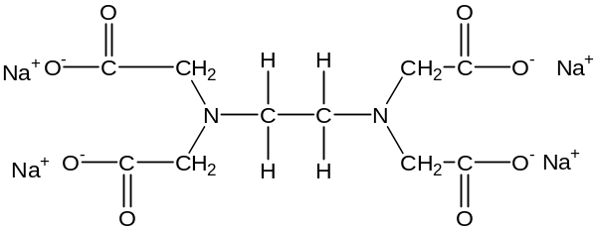
  complex | K_{stab}
  [Ca(edta)]²⁻ | 5 x 10¹⁰
  [Cd(edta)]²⁻ | 4 x 10¹⁶
  [Zn(edta)]²⁻ | 3 x 10¹⁶
 |  | (i) | Copy out the formula of EDTA and underline on your diagram the six atoms that form bond with the metal ions.
 |  | (ii) | Cadmium ions are poisonous as they can cause bone porosity by replacing the calcium ions in bones. One treatment for cadmium poisoning involves administering a solution of EDTA.  Calcium and zinc are essential for health.  Using the data given, explain how EDTA alleviates cadmium poisoning.  Comment on a likely problem that might arise during the treatment, and suggest how the problem can be overcome.
 |  |  |  | [4]
 | (e) | A useful commercial source of magnesium is seawater, where [Mg²⁺(aq)] is 0.0540 moldm⁻³. The magnesium is precipitated from solution by adding calcium hydroxide.  Mg²⁺(aq) + Ca(OH)₂ (s) → Ca²⁺(aq) + Mg(OH)₂(s)
 |  | (i) | Write an expression for the K_{sp} of Mg(OH)₂, including its units.
 |  | (ii) | The numerical value for K_{sp} is 2.00 x 10⁻¹¹.  Calculate [Mg²⁺(aq)] in a saturated solution of Mg(OH)₂.
 |  | (iii) | Hence calculate the maximum percentage of the original magnesium in the seawater that this method can extract.
 |  |  |  | [4]
 |  |  | [Total: 20]

2 | (a) | One of the compounds that contributes to the smell of roses, carnations, hyacinths and many more other flowers is Compound Y. It is widely used in perfumery, and it is the basis of all rose-smelling perfumes. Compound Y can be synthesised from phenylethanoic acid by the sequence of reactions shown below.  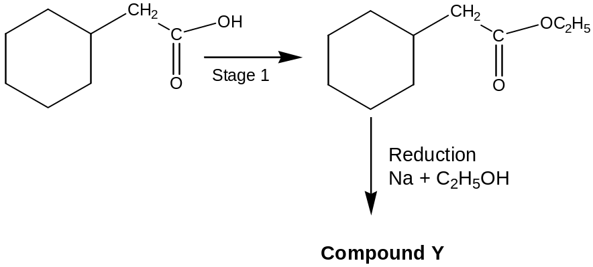
 |  | (i) | High resolution mass spectrometry shows that the accurate relative molecular mass of Compound Y is 122.08. Three possible molecular formulae for Compound Y, with relative molecular masses close to this value, are C₇H₆O₂, C₈H₁₀O and C₉H₁₄.  Accurate relative isotopic masses for the most abundant isotopes of carbon, hydrogen and oxygen are:  H = 1.008, C = 12.000, O = 15.995  Show how these isotopic masses can be used to determine which of the three possibilities is the molecular formula of Compound Y.
 |  | (ii) | State the reagents and conditions needed to carry out Stage 1 of the reaction sequence.
 |  | (iii) | It is thought that the sensation of smell is triggered by molecules which fit into smell receptors in the nose. There are probably several types of smell receptors, each type having a particular shape and containing particular chemical groups. The structures of three compounds, which have floral smells similar to Compound Y, are shown below.  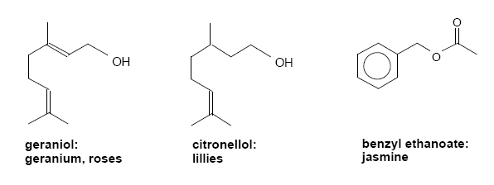  Suggest the common features possessed by the molecules of these three compounds that could be responsible for their similar smell.
 |  | (iv) | Using information in (a)(iii), together with your answer in (a)(i) suggest a structural formula for Compound Y.
 |  |  |  | [6]
 | (b) | Suggest how each of the following multi-step transformation can be achieved. Indicate reagents and conditions you would use for each step, but do not give experimental details.
 |  | (i) | 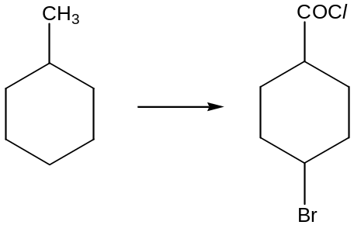
 |  | (ii) | 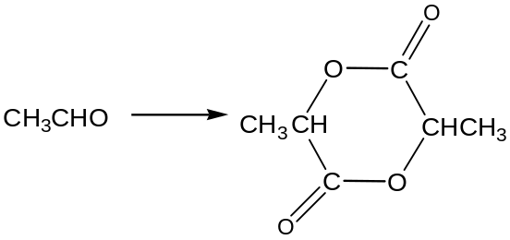
 |  |  |  | [6]
 | (c) | α-Terpineol, C₁₀H₁₈O, contains an alcoholic group which is not readily oxidized. On hydrogenation in the presence of palladium catalyst it gives U, C₁₀H₂₀O. U reacts readily in the presence of a few drops of concentrated sulfuric acid to give V, C₁₀H₁₈, which can be hydrogenated to give the compound below.  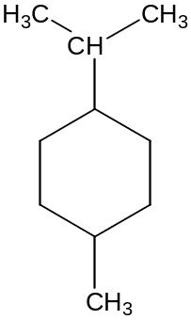  V is oxdised by warm acidified KMnO₄ to give W, C₉H₁₆O which gives a yellow precipitate on warming with alkaline aqueous iodine.  Heating α-terpineol with concentrated acidified KMnO₄ gives, X, C₁₀H₁₈O₄, which gives a yellow precipitate on warming with alkaline aqueous iodine.  Explain each step in this sequence, and deduce a structural formula for U, V, W and X. Hence deduce the structure for α- terpineol.
 |  |  |  | [8]
 |  |  | [Total: 20]

3 | Enzymes typically have the ability to increase the rate of reactions by factors of 10⁶−10¹², and this is particularly important in living organisms because they permit reactions to take place at reasonable rates even under the mild conditions that exists in living cells.
 | (a) | Pepsin is a digestive enzyme found in gastric juice that contains 327 amino acid residues in a single polypeptide chain, including the following amino acids:
  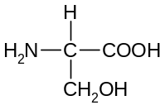 | 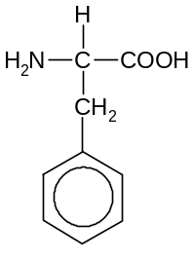 | 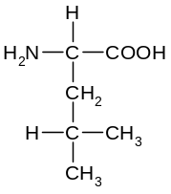 | 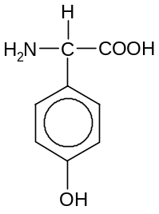
  serine (ser) | phenylalanine (phe) | leucine (leu) | tyrosine (tyr)
 |  | (i) | Draw the predominant species of tyrosine when it is placed in a solution of pH 12.
 |  | (ii) | Draw the displayed formula of −ser−leu−phe−, which is a segment of the polypeptide chain in pepsin.
 |  | (iii) | Draw a diagram to show the interactions involved between segments of pepsin that is involved in maintaining the secondary structure of the polypeptide chain.
 |  | (iv)  A | Phenylalanine can be synthesized from either of the two bromo compounds A and C.  Suggest reagents and conditions for step I, and draw the structural formula of the intermediates B and D.
  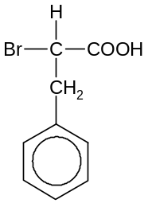  ethanolic NH₃  heat in sealed tube | B  titrate against  HCl(aq), till neutral
  titrate against
  NaOH(aq), till neutral
  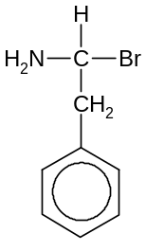  Step I  C |  |  | D |  | HCl(aq)  heat | 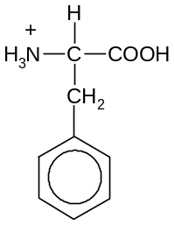
 |  |  | [8]
 | (b) | The hydrolysis of sucrose can be catalysed by the enzyme invertase, or by dilute acids. The initial reaction of the hydrolysis can be represented by:  C₁₂H₂₂O₁₁ + H₂O C₆H₁₂O₆ + C₆H₁₂O₆  sucrose glucose fructose  The following results were obtained using hydrochloric acid as the catalyst:
  Experiment | [HCl]  / moldm⁻³ | [Sucrose]  / moldm⁻³ | Initial rate  / moldm⁻³s⁻¹
  1 | 0.10 | 0.10 | 0.024
  2 | 0.10 | 0.20 | 0.048
  3 | 0.20 | 0.30 | 0.144
 |  | (i) | Use these data to deduce the order of reaction with respect to HCl and sucrose.  Hence, give the rate equation for the reaction and calculate the rate constant for the reaction, stating its units.
 |  | (ii) | Given that the half-life of sucrose in experiment 1 was 3.0s, predict a value for the half-life of sucrose in experiment 3, giving your reasoning.
 |  |  |  | [6]
 | (c) | D−glucose exist in two optically active forms, as shown in the following equilibrium:  A 1.0 moldm⁻³ aqueous solution of the α−form has an optical rotation angle of +112° while a 1.0 moldm⁻³ aqueous solution of the β−form has a optical rotation angle of +19.0° at 298K.
  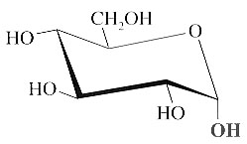 |  | 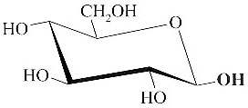 | , ΔH^{θ} = −2.10 kJmol⁻¹
  α−glucose(aq) |  | β−glucose(aq)
 |  | (i) | If either of the solutions containing one of the forms of glucose is allowed to stand, the optical rotation changes until it reaches +52.0º.  Given that the optical rotation angle is proportional to the concentration for each form of glucose, show that the equilibrium mixture contains 35.5% of the α-form.
 |  | (ii) | Write an expression for K_{c} and calculate its value at 298K.
 |  | (iii) | State and explain whether the optical rotation would be more than or less than +52° at 350K.
 |  |  | [6]
 |  |  | [Total: 20]

4 | One major use of chlorine is in the manufacture of sodium chlorate(I), NaClO, used in solution as a household bleach.
 | (a) | Sodium chlorate(I) is formed when chlorine gas is bubbled through aqueous sodium hydroxide, NaOH(aq), at room temperature. In the reaction, chlorine undergoes disproportionation.
 |  | (i) | Write a balanced equation to represent this reaction.
 |  | (ii) | With reference to the changes in the oxidation state of chlorine, explain what is meant by the term in italics.
 |  |  | [2]
 | (b) | The concentration of the chlorate(I) ions in household bleach can be determined by acidifying with hydrochloric acid, HCl, to produce chlorine gas by the following equation:  ClO⁻(aq) + 2H⁺(aq) +Cl⁻(aq) → Cl₂(aq) + H₂O(l)  In a typical experiment, a 25.0 cm³ sample of household bleach is diluted to  250 cm³. Excess hydrochloric acid was added to a 10.0 cm³ portion of this diluted solution, followed by excess potassium iodide solution. The iodine produced required 18.50 cm³ of 0.200 moldm⁻³ sodium thiosulphate, Na₂S₂O₃, for complete reaction.  Calculate the concentration of sodium chlorate(I) in the household bleach.
 |  | [4]
 | (c) | The lattice energy of sodium chlorate(I) can be determined from a hypothetical Born-Haber cycle using the following data:
   | ΔH / kJmol⁻¹
  Na(s) → Na(g) | +107
  Cl(g) + O(g) → ClO(g) | −269
  ClO(g) + e → ClO⁻(g) | −506
  Na(s) + ½Cl₂(g) + ½O₂(g) → NaClO(s) | −564
 |  | (i) | Define what is meant by the term lattice energy.
 |  | (ii) | Construct a labelled Born-Haber cycle for sodium chlorate(I), and use the cycle to calculate the lattice energy of sodium chlorate(I). Incorporate the data above as well as relevant data given in the Data Booklet.
 |  | (iii) | Explain how you would expect the numerical magnitude of the lattice energy of sodium chlorate(I) to compare with that of sodium chloride.
 |  |  | [7]
 | (d) | Chlorine can be manufactured by the electrolysis of brine, NaCl(aq), using a diaphragm cell.
 |  | (i) | In a small-scale experiment conducted in the laboratory, a steady current of 2.0 A was passed through the cell for 30 minutes.  Assuming ideality, calculate the volume of chlorine gas collected at 27°C and 1.5 atm.
 |  | (ii) | Under what conditions of temperature and pressure would you expect the behaviour of chlorine gas to be most like an ideal gas?
 |  | (iii) | With reference to relevant electrode potential in the Data Booklet, explain why fluorine gas cannot be prepared by electrolysis of aqueous sodium fluoride, NaF(aq).
 |  |  | [7]
 |  |  | [Total: 20]

5 | Chlorine is a pale yellow-green gas that forms a variety of inorganic and organic compounds.
 | (a) | The table below shows some properties of certain Period 3 chlorides.
   | NaCl | MgCl₂ | AlCl₃ | PCl₃
  Melting point / °C | 801 | 700 | 178 | −92
  pH of a 1 moldm⁻³ solution in water | 7 | 6.5 | 3.0
 |  | (i) | Describe the bonding and structure in NaCl and PCl₃, and suggest a reason for the difference in the bonding of these two chlorides.  Hence, account for the difference in the melting point of these two chlorides.
 |  | (ii) | Suggest, with a reason, another difference in the physical property of NaCl and PCl₃.
 |  | (iii) | With the aid of an equation, show that the pH of a solution of MgCl₂ is lower than 7.
 |  | (iv) | Describe and explain what would be observed when water is gradually added to PCl₃, until in excess. Suggest a value of the pH of the resulting solution.
 |  |  | [10]
 | (b) | In an experiment, propane was reacted with limited chlorine in the presence of ultraviolet light.
 |  | (i) | Suggest why ultraviolet light is required for the reaction to occur.
 |  | (ii) | Write down the formula of an intermediate organic species in the reaction mechanism.
 |  | (iii) | Assuming that only mono-chlorination takes place, and the reaction occurs at the same rate at all carbon atoms, predict the ratio of the products formed.
 |  |  | [4]
 | (c) | Compound D, C₉H₈O, insoluble in water and aqueous sodium hydroxide, reacts with chlorine gas in the dark to form E, C₉H₈OCl₂. D does not react with Fehling’s solution but reacts with Tollen’s reagent to give a silver mirror. On heating with acidified potassium manganate(VII), D produces F, C₈H₆O₄, which is soluble in sodium hydroxide.  Deduce the structures of compounds D, E, and F, and explain the chemistry of the reactions involved.
 |  | [6]

~ END OF PAPER ~

